**ATTENTION. NEVER EVER DELETE OR ALTER FILE NAMED "res.json". EVERYTHING THAT WAS EXTRACTED FROM THE SITE IS STORED IN THIS FILE.**

**A) Filling in queries.txt file:**

1. Copy entire column of new queries from Excel.

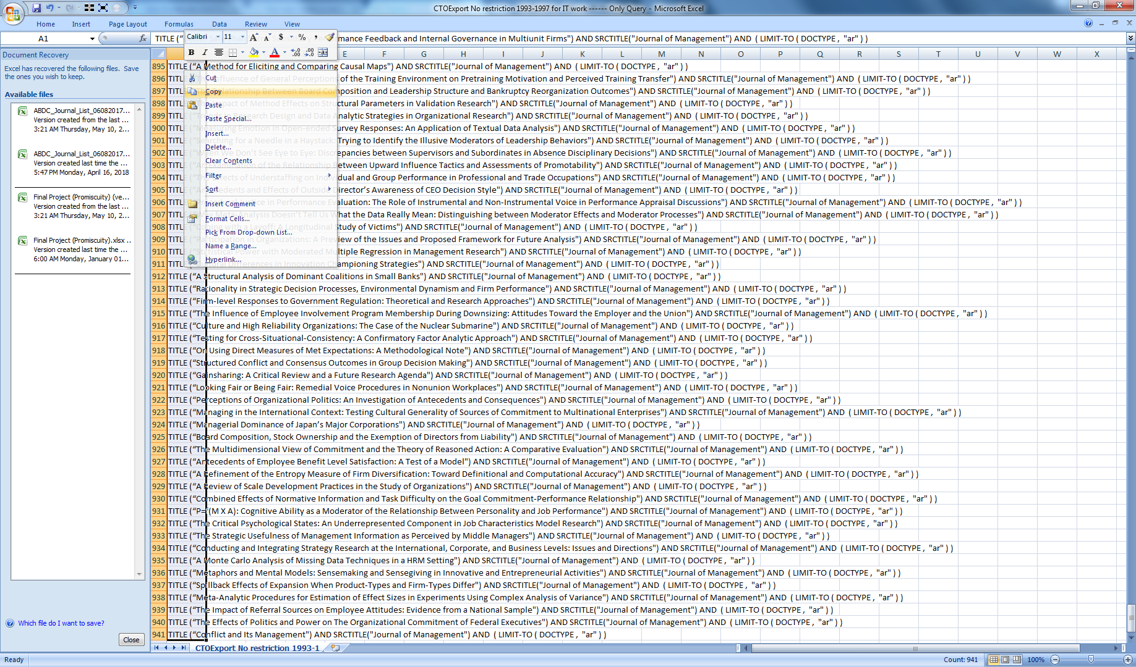

2. Open folder "Downloads"->"SCOPUS PROJECT"->"scopus-master"

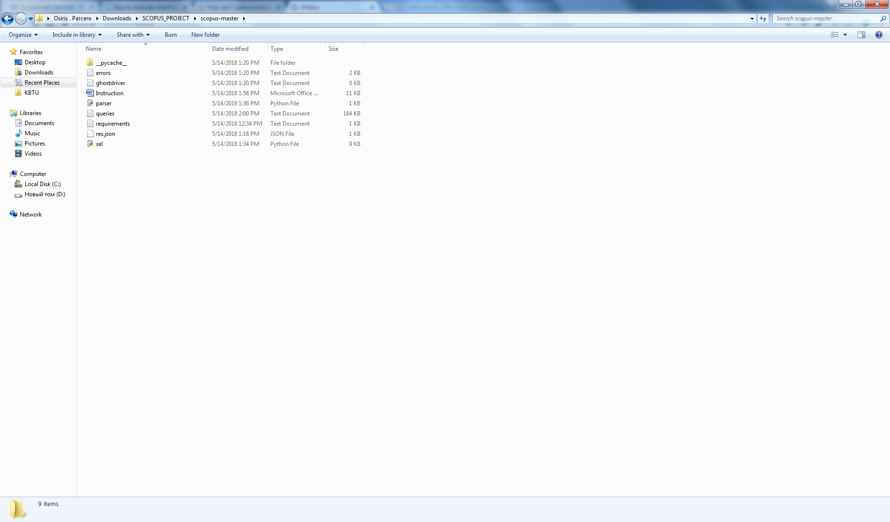

3. Open file "queries.txt" (It also can appear as "queries").

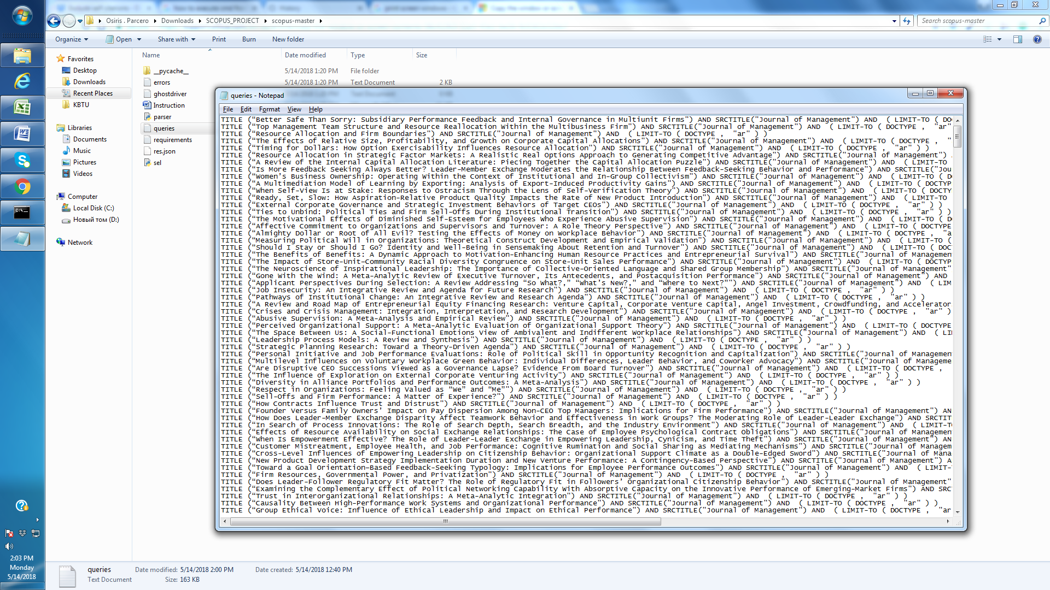

4. Erase everything from the file (if you do not delete previous queries from the file, the program will make these queries again).

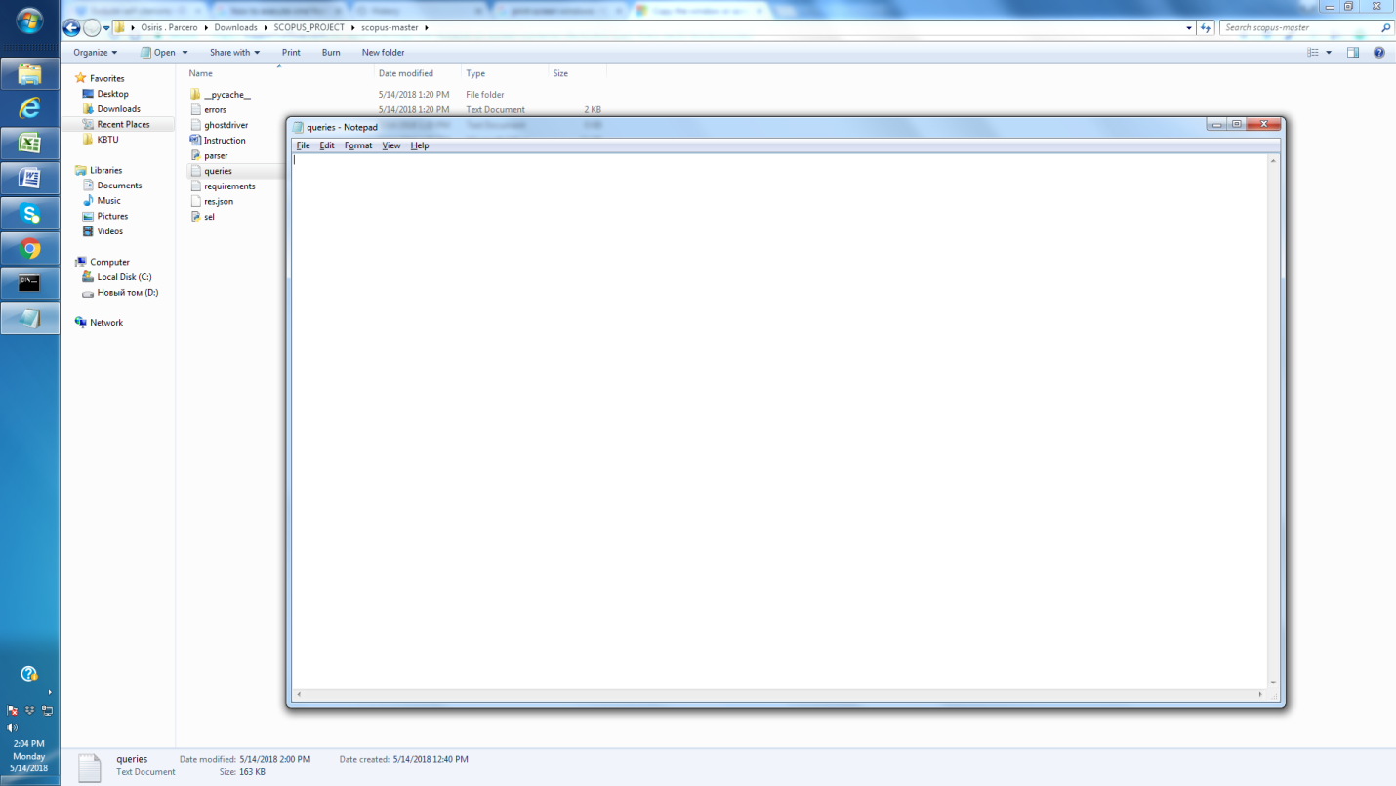

5. Paste data of copied column (queries from Excel).

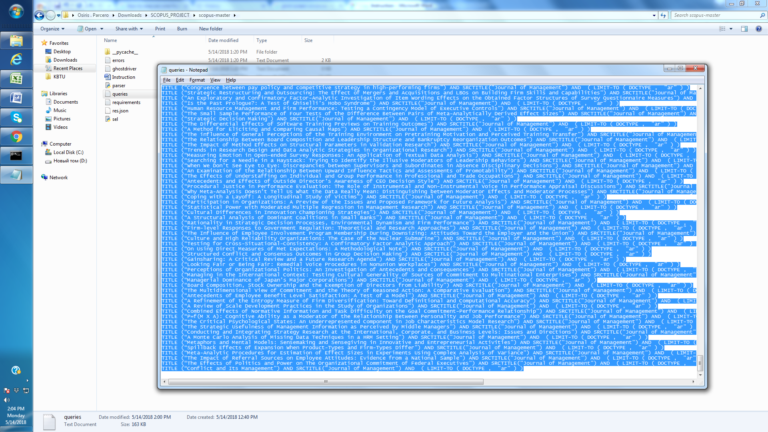

6. Save and close the file.

7. Go to step B.

**B) Executing program:**

1. Open folder "Downloads"->"SCOPUS PROJECT"->"scopus-master"



2. Press on address bar, select the address of the directory. Type "cmd" instead of the address (without quotes). Press Enter. You will see black window with white letters.

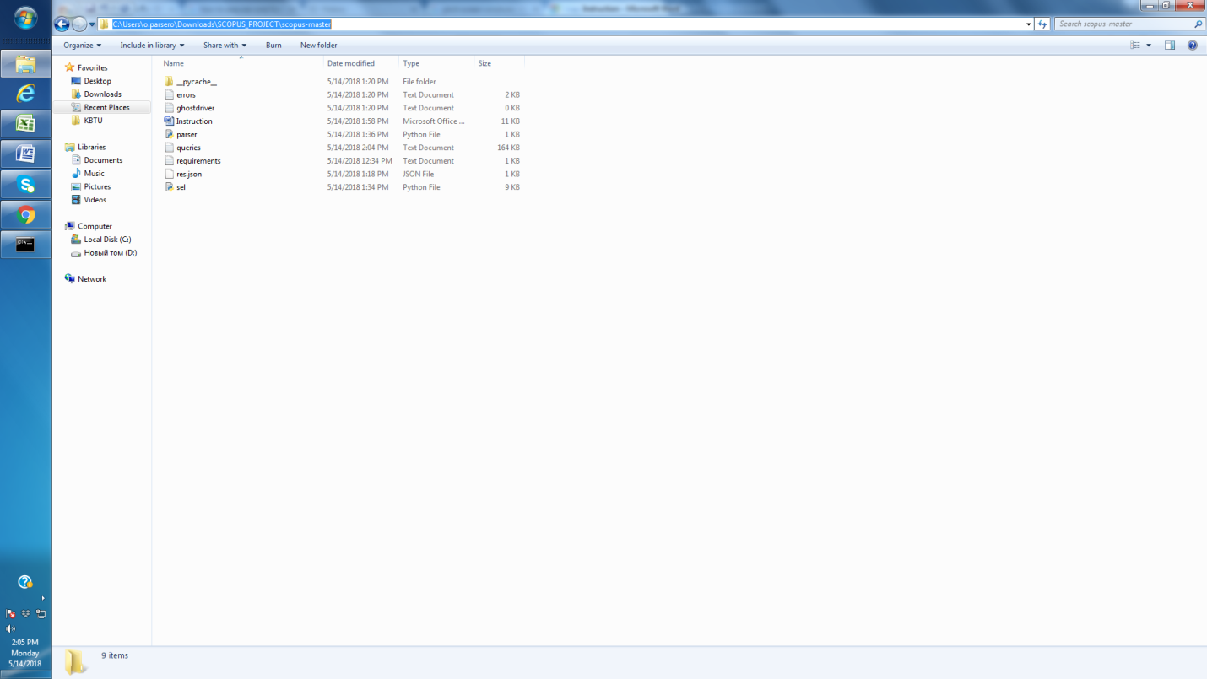

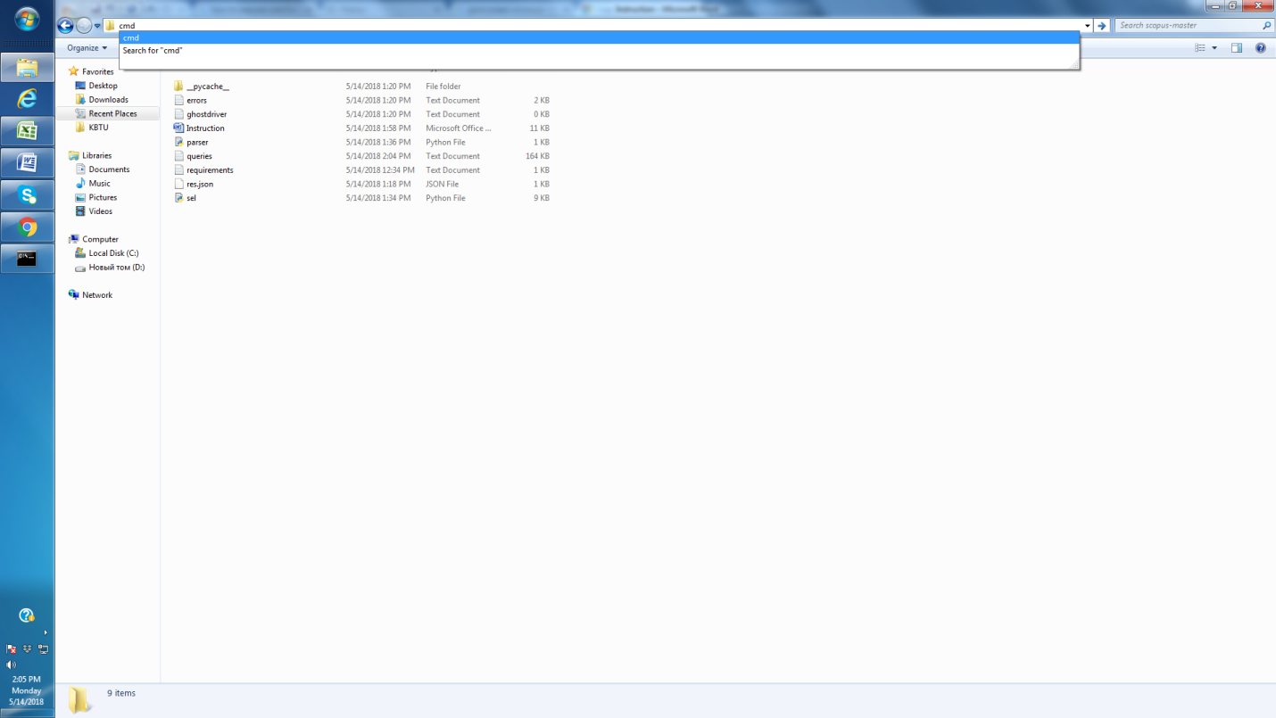

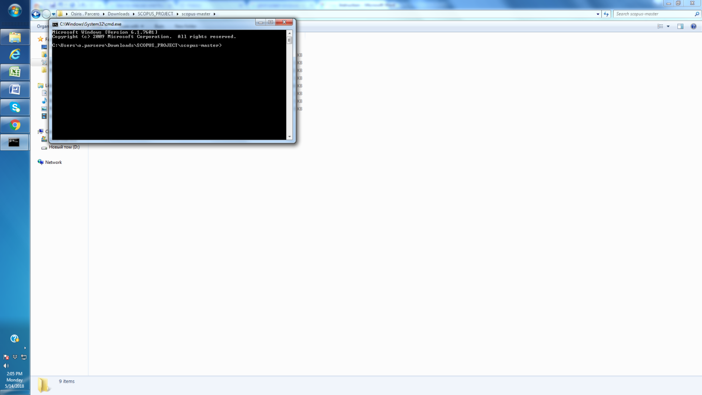

3. In the "cmd" window type following: "python parser.py" (without quotes). Press Enter.

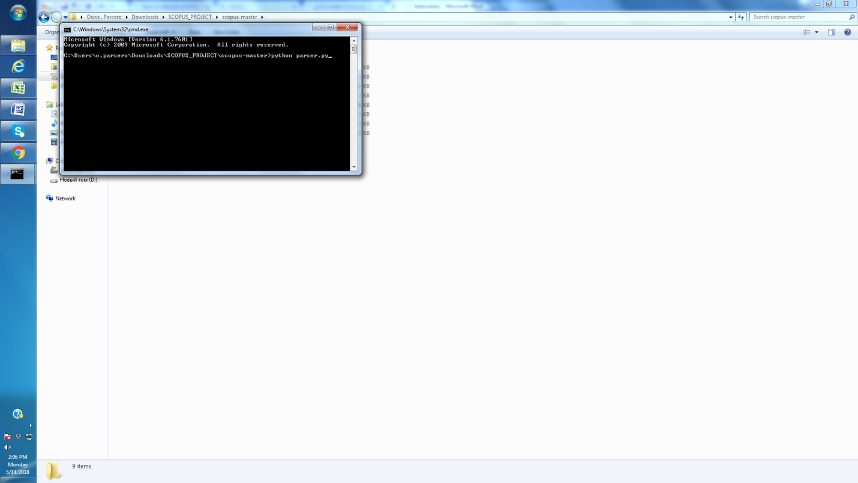

4. Execution of program is started. It is okay, if you see chrome browser opening and closing. It means that the program is working.

5. Whenever you see message "FINISHED. Execution took X hours." on "cmd" window, close the "cmd" window. The message is displayed in several hours after execution.

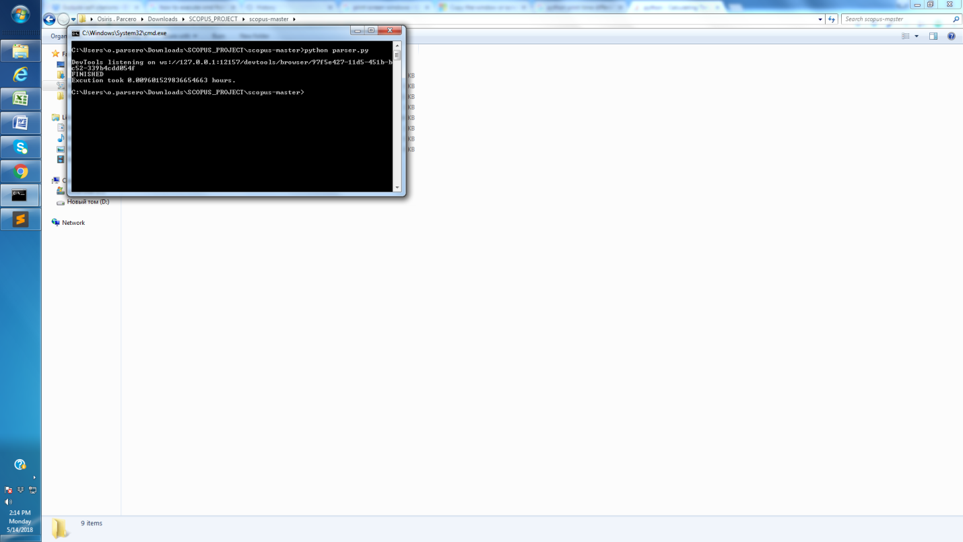

6. Go to step A.

All the data is collected in file "res.json"

**PROGRESS**

Journal of Management, successful as shown below (21/05/2018).

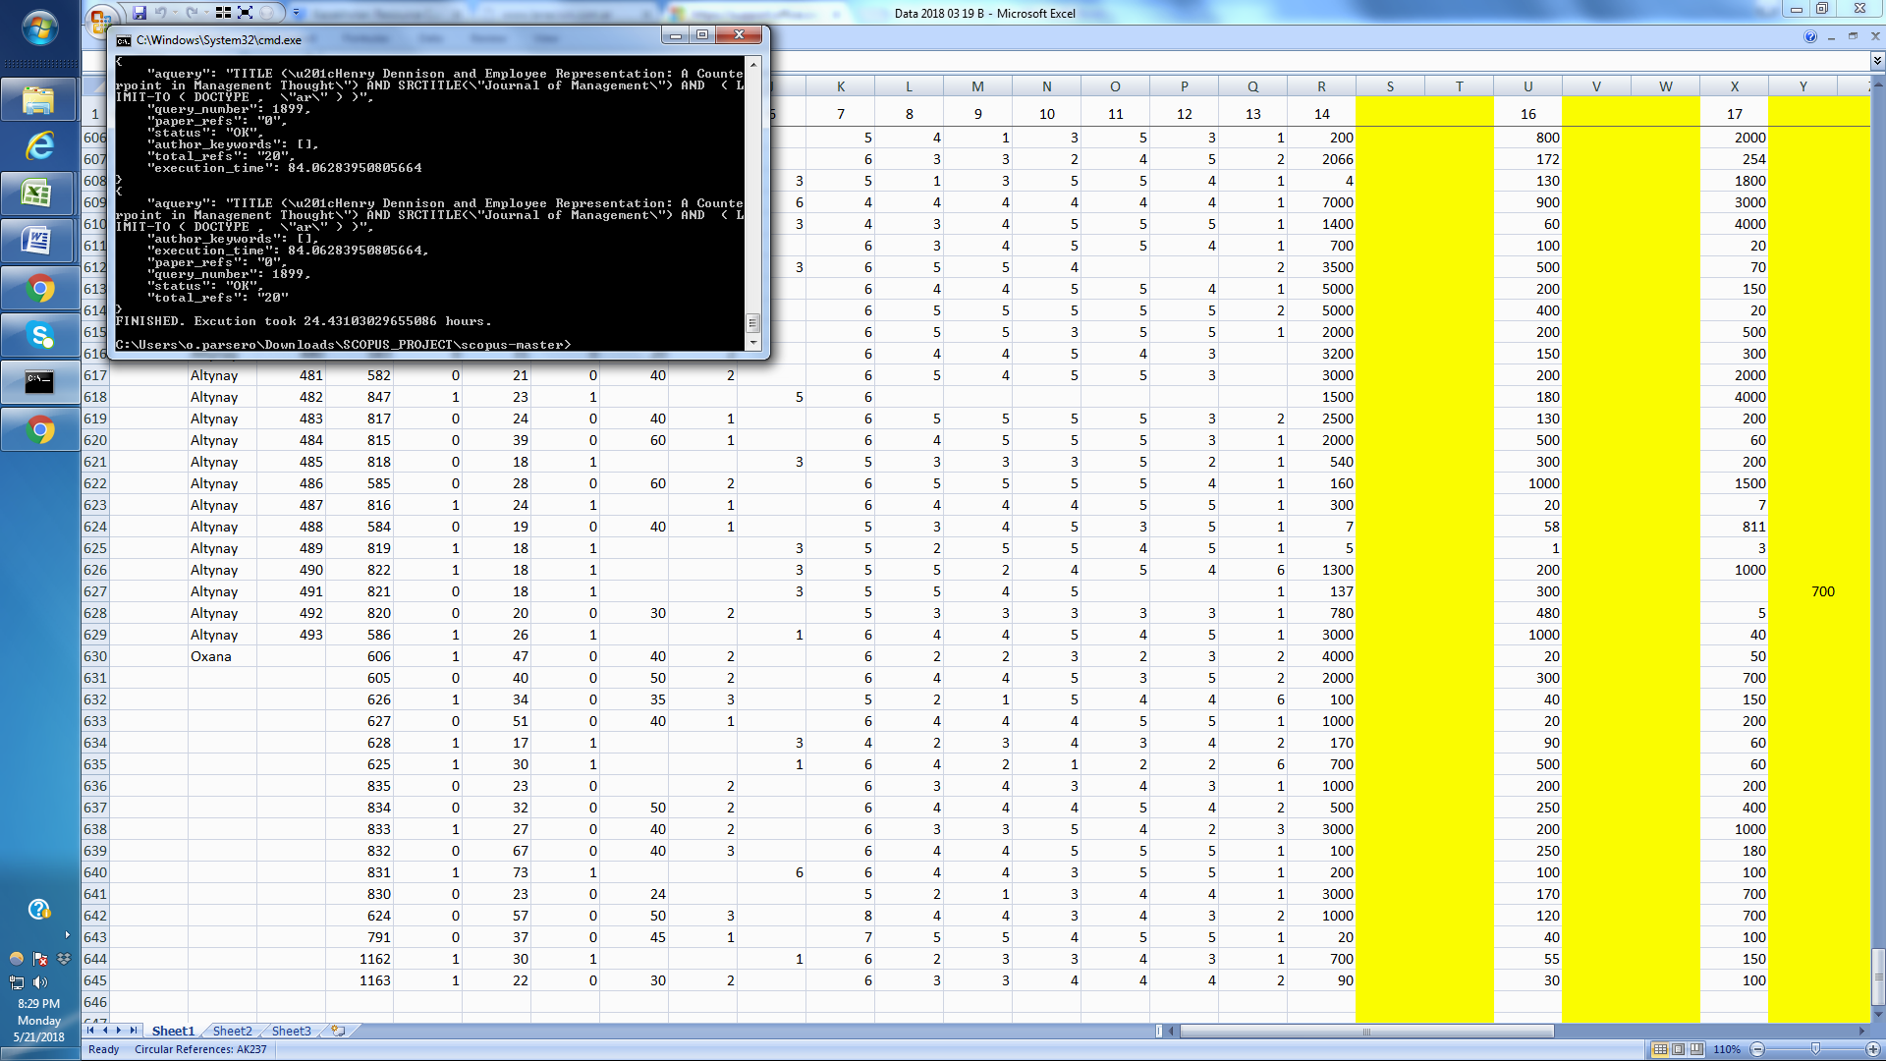

Academy of Management Journal a

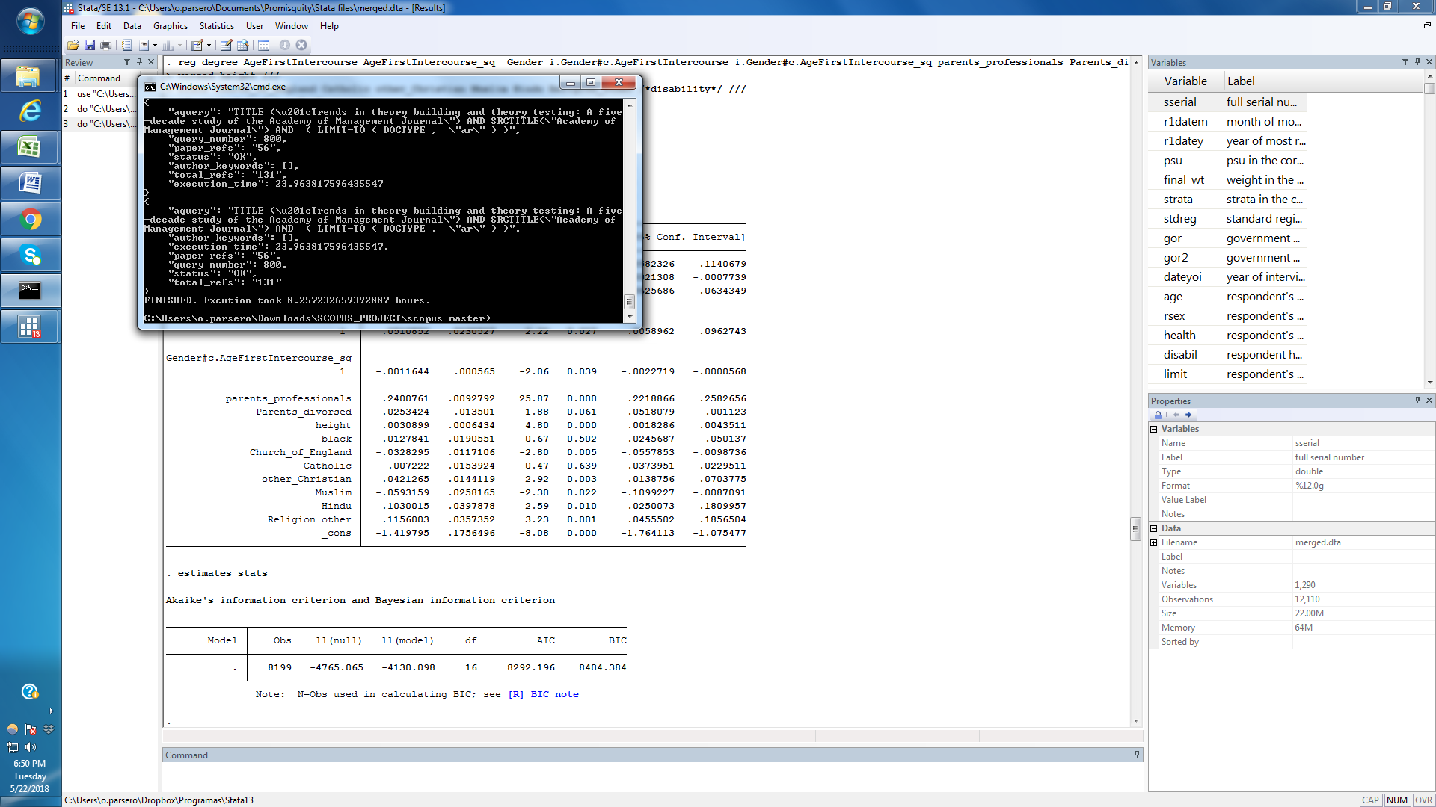

Academy of Management Journal a

journal of general management (ERROR MESSAGE BELOW)

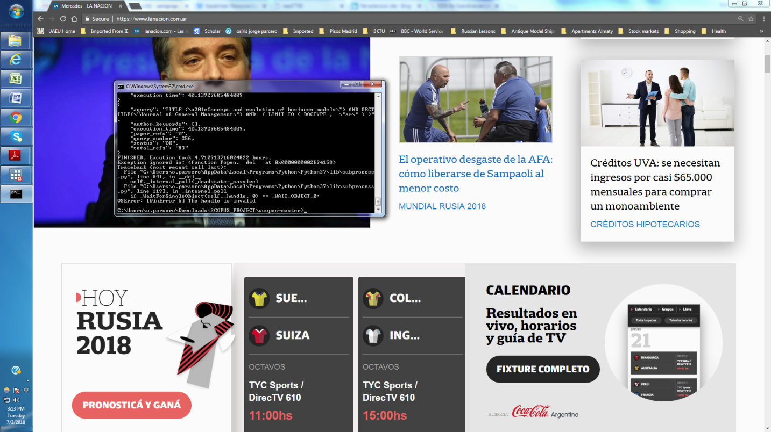

Journal of Management and Organization

The computer got stuck (not even the mouse could move) on 03/07/2018. I am trying a second time. The second time I did it I got the following error:

